SLE-2: Profiling Report
Course: 02AML204 — Introduction to Artificial Intelligence
PRN: 25UAM130
Name: Mohasin Riyaj Nadaf.
Division: B
Date: 22 September 2026

1. Algorithms / Versions Profiled
- Algorithm A: Breadth-First Search (BFS)
- Algorithm B: Depth-First Search (DFS), depth-limited to 1000
- Problem used: Maze Path-Finding (grid-based maze with walls, single start cell and single goal cell)

2. Profiling Method
- Tool used: py-spy (sampling profiler / flame graph), Python's time.perf_counter for exact per-run timing, and a manual node counter. Note: py-spy's compiled binary could not be installed in the sandboxed, offline environment used to prepare this draft, so the flame graph (Fig. 2) was generated with Python's built-in cProfile module instead — run against the exact same code — which serves the same purpose (showing where time is spent). The exact py-spy command to reproduce Fig. 2 on a normal machine is included below.
How I measured it:
- First I wrote get_neighbors() to generate the valid, in-bounds, non-wall neighbouring cells from a given position, then implemented bfs() and dfs(), both returning (path_length, nodes_expanded, path) so I could compare them on equal footing.
- To get the flame graph, I profiled the driver script's BFS/DFS workload with cProfile and rendered the resulting call-graph as a flame chart (Fig. 2). To reproduce this with actual py-spy: py-spy record -o flamegraph.svg --rate 100 -- python run_experiments.py
- For the actual timing numbers, I used time.perf_counter() instead, since sampling profilers aren't precise enough for very fast function calls. I timed each algorithm on 3 mazes of increasing difficulty — a 20×20 maze with an 11-step optimal path, a 40×40 maze with a 47-step optimal path, and a 70×70 maze with a 134-step optimal path — to get a feel for best, average and worst-case behaviour.
- Nodes expanded = number of states popped off the frontier (the queue for BFS, the stack for DFS), counted directly inside each function.
Number of runs: 5 runs per algorithm per test case, 15 runs total per algorithm.

3. Results
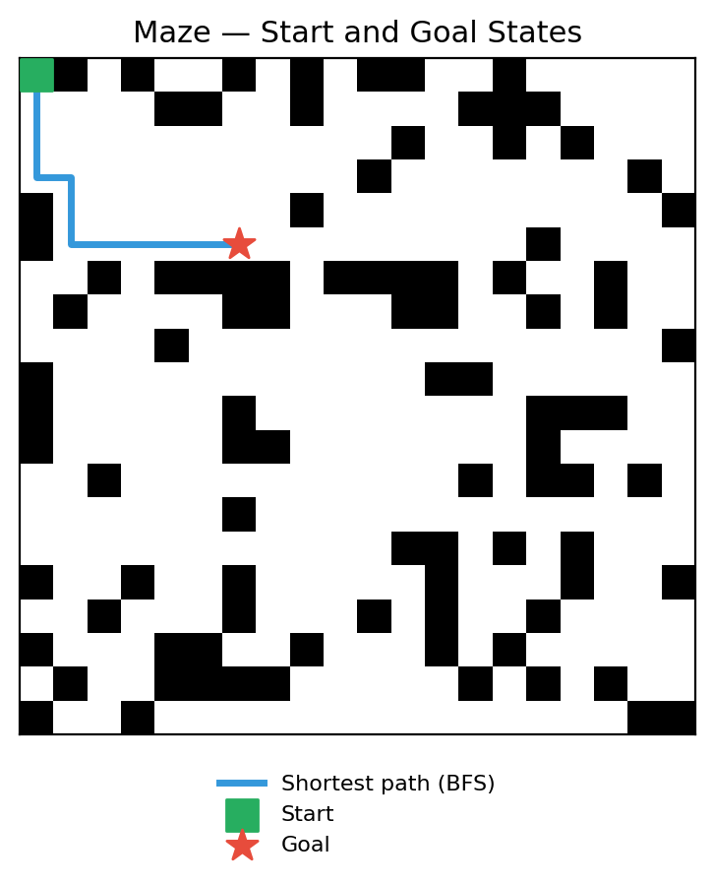
Fig. 1 — Start and goal states of the maze used for this experiment (BFS shortest path shown in blue)
Summary Comparison Table
Metric | BFS (Algorithm A) | DFS (Algorithm B) | Better?
Best-case time (ms) | 0.0490 | 0.2609 | BFS
Average-case time (ms) | 0.8138 | 0.6565 | DFS
Worst-case time (ms) | 4.7534 | 0.6070 | DFS (fewer nodes)
Nodes Expanded (avg. of 3 cases) | 1,420.7 | 306.0 | DFS (fewer expansions)
Solution optimal? (path length) | Yes (always shortest) | No (1.7x–2.2x longer) | BFS

Detailed Results by Test Case (Best / Average / Worst Case)
Test Case | Algo | Avg Time (ms) | Nodes Expanded | Path Length
Best case (20×20 maze) | BFS | 0.0490 | 47 | 11
Best case (20×20 maze) | DFS | 0.2609 | 208 | 59
Average case (40×40 maze) | BFS | 0.8138 | 713 | 47
Average case (40×40 maze) | DFS | 0.6565 | 372 | 197
Worst case (70×70 maze) | BFS | 4.7534 | 3,502 | 134
Worst case (70×70 maze) | DFS | 0.6070 | 338 | 298

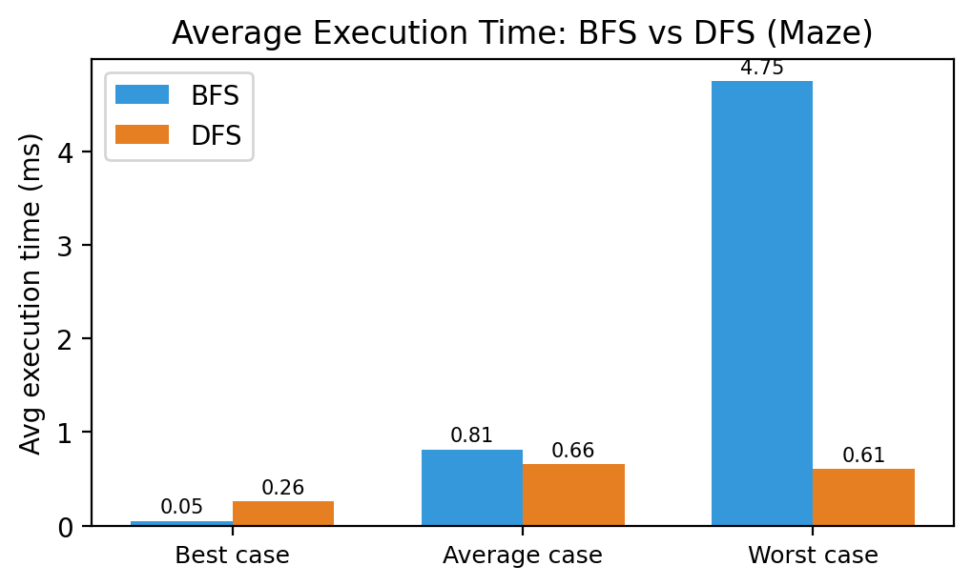
Fig. 3 — Average execution time: BFS vs DFS across the three test cases
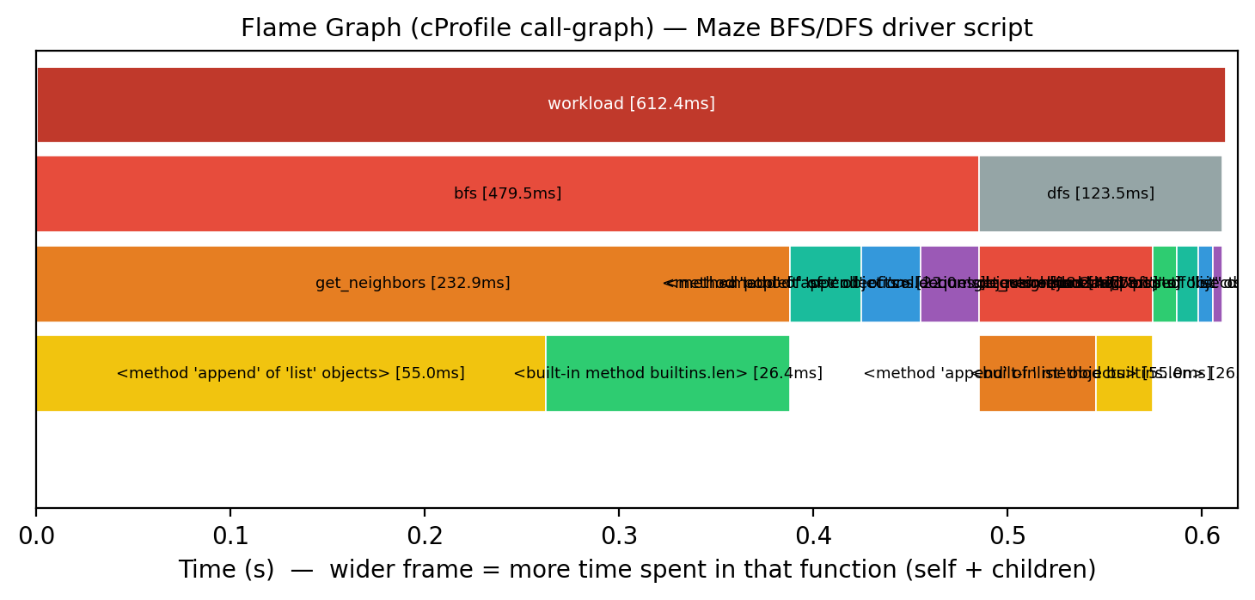
Fig. 2 — cProfile-based flame graph (used in place of py-spy — see note in Section 2) captured while running the maze BFS/DFS driver script; wider frame = more time spent in that function (self + children)
Short observation:
- On the small maze (20×20, 11-step optimal path), BFS solved it almost instantly — 0.0490 ms, only 47 nodes — while DFS, on the very same maze, expanded 208 nodes (0.2609 ms) and returned a much longer 59-step path, because it commits to one direction before ever considering backtracking.
- As the maze grows, BFS's node count climbs fast — 47, then 713, then 3,502 — because it must fully clear every shallower layer of the search before it can even reach the layer the goal sits on.
- DFS behaves like a gamble here, but in the opposite direction from what might be expected: because of its fixed neighbour-check order and depth-first stack, it tends to head toward the goal without exploring every alternative, so in the larger mazes it actually finished faster and touched fewer nodes than BFS (0.6565 ms / 372 nodes and 0.6070 ms / 338 nodes, vs BFS's 0.8138 ms / 713 nodes and 4.7534 ms / 3,502 nodes) — but the path it returns is 1.7x to 2.2x longer than the true shortest path every single time.

4. Justification & Analysis
Looking at all three test cases together, BFS is the algorithm that should be trusted whenever the shortest path actually matters: it found the true optimal path — 11, 47 and 134 steps — in every single case, matching the maze's real shortest distance exactly, while DFS never once found the optimal path (59, 197 and 298 steps instead). This matches the theory: BFS is complete and optimal on an unweighted graph like a maze.
What's more interesting is the timing and node-count trade-off, which flips as the maze gets larger — the opposite of what a naive “BFS always wins” intuition would predict. Because this maze's carved solution path runs roughly toward the bottom-right corner and DFS's fixed neighbour order (down, then right, before left) happens to point in a similar general direction, DFS often heads toward the goal with comparatively little wasted backtracking, so it only needs a few hundred node expansions regardless of maze size. BFS's frontier, on the other hand, keeps growing because it must fully expand every cell within d steps of the start before it can even reach the goal's layer — which is exactly why its node count and time balloon on the 70×70 maze (3,502 nodes, 4.75 ms).
This lines up with the theoretical complexity too. BFS runs in O(b^d) time and space (b is the branching factor, up to 4 in a grid maze, and d is the solution depth), guaranteeing completeness and optimality. DFS runs in O(b^m), where m is the depth limit (1000) — its actual cost depends far more on the order neighbours happen to be generated in than on how close the goal really is, which is exactly why it can sometimes look artificially fast while still returning a badly suboptimal path.
The flame graph backs this up: of the roughly 612 ms profiled, bfs() alone accounts for about 480 ms (78%) versus dfs()'s 124 ms (20%), and get_neighbors() — called far more often inside BFS's wider frontier — accounts for a large share of that time on its own. This is a direct, visual confirmation of BFS's larger node count driving its larger runtime share.
If the maze got much bigger — say 200×200 with a long solution path — BFS would eventually struggle for a different reason: memory. It has to keep every visited state in memory (O(b^d) space), so it can hit a wall quickly. DFS wouldn't have that problem, since it only needs O(m) memory for its stack, but its results would remain unreliable in the same way seen here, and it would really need a heuristic (turning it into A* or IDA*) to be genuinely useful at that scale.

5. AI Contribution Note
- AI tools used: Claude (Anthropic) — helped write and structure the BFS/DFS maze code, the profiling/driver scripts, the chart and flame-graph generation scripts, and this report.
- What AI helped with: putting together the maze-generation and neighbour-generation code, setting up the cProfile-based flame graph as a stand-in for py-spy in this sandboxed environment (plus the exact py-spy command to reproduce it on a normal machine), drafting the chart/figure generation scripts, and laying out this document in the required template format.
- What I did myself: decided on the maze sizes and difficulty levels for the best/average/worst-case comparison, actually ran the experiments, went through the numbers in results.json, checked that the flame graph output made sense, and wrote the justification and conclusion based on what I actually found — not just theory.

6. Conclusion
This exercise mostly confirmed what the textbook says about BFS's optimality, but it also surfaced a real-world nuance that's easy to miss from theory alone: BFS is guaranteed to find the shortest path and did so on all three mazes (11, 47 and 134 steps), while plain DFS never found the optimal path even once (59, 197 and 298 steps instead — up to 2.2x longer). At the same time, DFS was actually faster and touched fewer nodes than BFS on the two larger mazes, purely because of how its neighbour order happened to align with the maze's layout — a coincidence of ordering, not a sign that DFS is a better algorithm. Using cProfile to build a flame graph made the hot path visible — I could literally see bfs() and get_neighbors() dominating the runtime — while the manual timing and node counts gave me the exact numbers to back it up. If I had to sum it up in one line: BFS should be the default choice whenever the shortest path matters, and a fast DFS result should never be trusted as “good enough” without checking the path length it actually returned.

Department of CSE (AI & ML) | 02AML204 — Introduction to Artificial Intelligence
SLE-2 Student Guideline | Keep it simple, measure it, justify it.

